COS10029-FUNDAMENTALS OF PROGRAMMING
Name: Sovithyea Prach
Student ID: 105270743
Task 5.1
a)
int i=1, num=2;
while (i<5)
{
num=num+i;
i++;
}
cout<<“i= “<<i<<”num=”<< num;
1 2 3 4 5
i
num
2 3 5 8 12
While condition
T T T T F
Output: i= 5 num=12

b) Hand execution for do ...while loop
int i=1, num=2;
do
{
num=num+i;
i++;
}while(i<5);
cout<<“i= “<<i<<”num = ”<<num;
1 2 3 4 5
i
num
2 3 5 8 12
While condition
T T T T F
Output: i=5 num=12

c). Hand execution for for loop
int i,num=0;
for (i=0;i<5;i++)
num=num+i;
cout<<“i = “<<i<<”num = “<<num;
0 1 2 3 4 5
i
condition
T T T T T F
num
0 0 1 3 6 10
Output: i=5 num=10
d) Nested loop
int i, j, count=0;
for (i=0; i<3; i++)
{
for (j=0; j<3; j++)
{
count++;
}
}
0 1 2 3
i
j
0 1 2 3 1 2 3 1 2 3 1 2 3
1 2 3 4 5 6 7 8 9
count

Task 5.2
Code:
#include <iostream>
using namespace std;

int main()
{
for (int i = 1; i <= 5; i++)
{
for (int j = 1; j <= 5; j++)
{
cout << i << " x " << j << " = " << i * j << endl;
}
}
return 0;
}
Output:
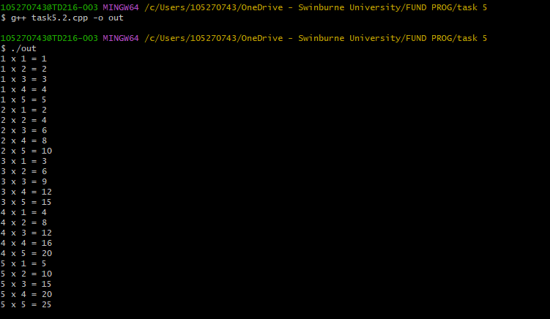
Task 5.3
Code:
#include <iostream>
using namespace std;

// Function prototypes
void addition();
void subtraction();
void multiplication();
void division();

int main() {
int choice;

do {
cout << "Enter your choice (1-5):" << endl;
cout << "1. Addition" << endl;
cout << "2. Subtraction" << endl;
cout << "3. Multiplication" << endl;
cout << "4. Division" << endl;
cout << "5. Exit" << endl;
cout << "Choice: ";
cin >> choice;

switch (choice) {
case 1:
addition();
break;
case 2:
subtraction();
break;
case 3:
multiplication();
break;
case 4:
division();
break;
case 5:
cout << "Exiting the program." << endl;
break;
default:
cout << "Invalid choice. Please enter a number between 1 and 5." << endl;
break;
}

} while (choice != 5);

return 0;
}

void addition() {
double num1, num2;
cout << "Enter two numbers for addition: ";
cin >> num1 >> num2;
cout << "Result: " << num1 + num2 << endl;
}

void subtraction() {
double num1, num2;
cout << "Enter two numbers for subtraction: ";
cin >> num1 >> num2;
cout << "Result: " << num1 - num2 << endl;
}

void multiplication() {
double num1, num2;
cout << "Enter two numbers for multiplication: ";
cin >> num1 >> num2;
cout << "Result: " << num1 * num2 << endl;
}

void division() {
double num1, num2;
cout << "Enter two numbers for division: ";
cin >> num1 >> num2;
if (num2 != 0) {
cout << "Result: " << num1 / num2 << endl;
} else {
cout << "Error: Division by zero is not allowed." << endl;
}
}

Output:
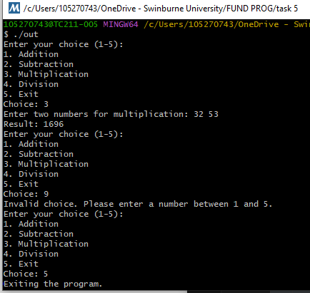
Task 5.4
Code:
#include "splashkit.h"
#define WIDTH 100
#define HEIGHT 100

int main()
{
double x, y;
open_window("Rectangle Moving", 800, 600);
x=350;
y=250;
while(not quit_requested())
{
process_events();
clear_screen(COLOR_WHITE);

fill_rectangle(COLOR_RED, x, y, WIDTH, HEIGHT);
if(key_down(DOWN_KEY) and y+HEIGHT<screen_height())
y = y+10;
if(key_down(UP_KEY) and y>=0)
y = y-10;
if(key_down(RIGHT_KEY) and x+WIDTH<screen_width())
x = x+10;
if(key_down(LEFT_KEY)and x>=0)
x = x-10;

refresh_screen(60);
}
return 0;
}

Output:
